1. 
2. In last lecture, we came to conclusion that the **Git Blob** that is stored under .git/objects/<Two-Char-From-40-Hash-Char>/<blob> doesn’t have the same file name as for the file it is created. Actually in Git repo, the file name is 38 characters hex.   
   The **Git** **Blob** has a name based on **SHA1 hash code** of that file.
3. 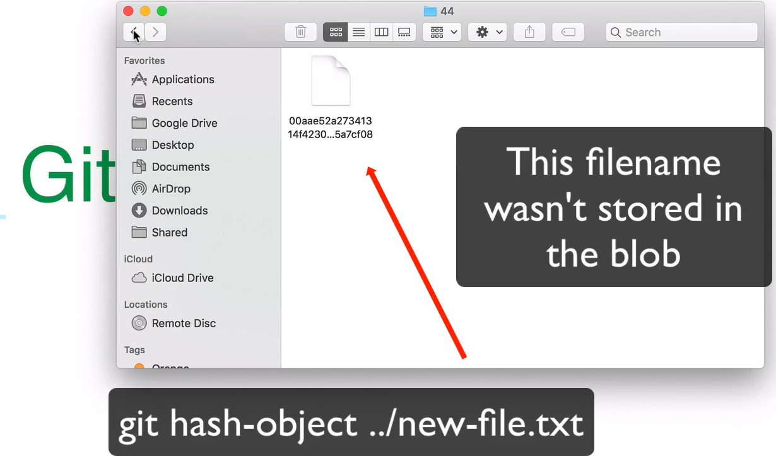
4. 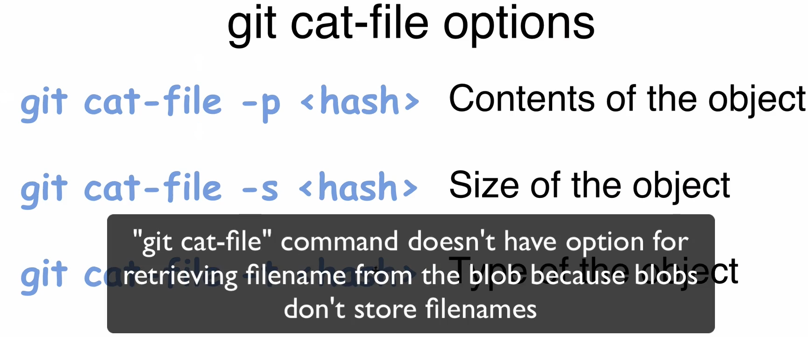  
   That is the answer to the question. ☺
5. 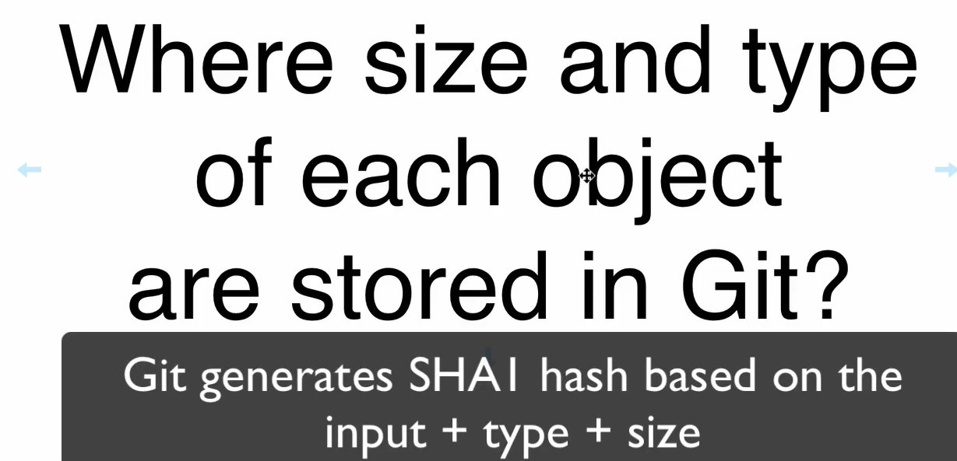  
   **Answer**: The size and type are stored inside the blob itself.  
   The following slide is based on the above slide question.   
   hash-object calculates hashcode based on input, type, size whereas shasum uses only input. So hashcodes are different by both even though same input file and input, type, size are stored in blob itself.  
   Text

   Description automatically generated
6. Let’s talk about the contents of Git Blob Object in the next lecture.